
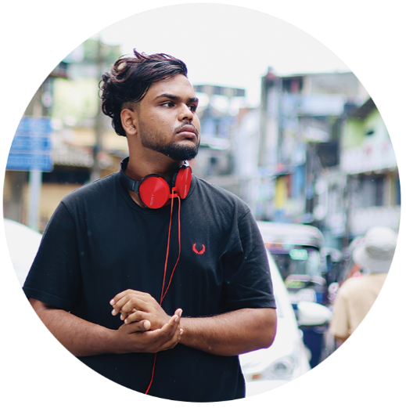







https://fathik.me/
SITE:
2022 - 2023
Web Developer & Designer
INNOROOT.LK | SRI LANKA
As a Web Developer and Designer at Innoroot.lk Company, I specialize in creating user-friendly and visually appealing websites. My role involves designing intuitive interfaces, developing responsive layouts, and ensuring seamless functionality across devices. I collaborate closely with clients to understand their needs and deliver tailored solutions that enhance user experience and drive engagement.
2020 - 2021
Graphic Designer and Video Editor
RADIO MANNAR | UK
As a Graphic Designer and Video Editor at Radio Mannar, I create visually compelling graphics and videos that enhance the station's brand and engage the audience. My responsibilities include designing promotional materials, editing video content for broadcasts, and collaborating with the creative team to produce high-quality media that aligns with our programming goals.
Labishanth,
based in Mannar, Sri Lanka, is a dynamic creative professional with diverse expertise in graphic and web design, video and VFX editing, animation, 3D modeling, photography, and cinematography. Highly skilled in industry-standard software like Adobe Creative Suite, Blender, and DaVinci Resolve, I produce captivating media across formats. Fluent in both Tamil and English, I blend technical precision with artistic insight to deliver compelling visual storytelling and design solutions.

2022 – 2023 ( Finished )
GCE ORIDINARY LEVEL
Mn/Siddhyvinayakar Hindu college
Completed GCE O/L at Mn/Siddhyvinayakar Hindu College from 2022 to 2023, achieving the best results and demonstrating a strong academic foundation.
2023 – 2024 (ON PROCESS)
HND IN SOFTWARE ENGINEERING
ESOFT METRO CAMPUS
Currently pursuing an HND in Software Engineering at ESOFT Metro Campus since 2023, enhancing technical skills and deepening expertise in software development.
OBS Final Cut Pro Microsoft Office Cubase Tough Designer

No16a Convent Road Sinnakkadai, Mannar, Sri Lanka
PROFESSIONAL SKILLS
Creative Visual Design Advance Video Editing & VFX
3D Modelling & Animation
Photography & Cinematography
Bilingual Communication
Davinci Resolve Audition Adobe FL Studio Ableton Live

TECHNICAL SKILLS
Blender Photoshop Adobe Illustrator Adobe Premiere Adobe After Effects
+94 070 603 1831
LABISHANTH
GRAPHIC & WEB DESIGNER
PHONE:
EMAIL:
Contact@fathik.me
ADDRESS:
EDUCATION
ABOUT
SKILLS
WORK EXPERIENCE
2022 - Present
Founder & CEO
STUDIO PIXEL PALS | SRILANKA
As the Founder and CEO of Studio Pixel Pals, I specialize in providing professional photography services that capture memorable moments and tell compelling stories. I oversee all aspects of the business, from client consultations to creative direction and post-production, ensuring high-quality images that exceed client expectations and reflect a unique artistic vision.
2022 - Present
Founder & CEO
FATHIK.COM | SRILANKA
As the Founder and CEO of Fathik.com, I lead a creative team in delivering innovative solutions in live streaming, cinematography, VFX, music production, graphics, 3D modeling, and animation design. My role focuses on strategic direction, fostering creativity, and ensuring high-quality services that meet client needs while adapting to industry trends.
WORK EXPERIENCE

ADITIONAL SKILLS

LANGUAGE SKILLS

Tamil (Native) 99%

English (Proficient) 80%

Sinhala (Basic) 15%

SKILLS

Graphic Design
Web Development
Video Editing
Animation
3D Modeling
Drone Piloting
Event Live Streaming
VFX (Visual Effects)
Photography
Cinematography
Music Production
Graphics Design
Digital Content Creation
Social Media Marketing
Color Correction
Photo Retouching
Motion Graphics
Storyboard Development
Client Consultation
Creative Direction
Project Management
Research and Trend Analysis
3D Modelling
Hardware Check-Up
PC Building
SEO (Search Engine Optimization)

2023 - Present
GRAPHIC DESIGNER & ANIMATOR
DIGITAL CLINIC | SRILANKA
In my role as a Graphic Designer and Animator at Digital Clinic Company, I created visually appealing graphics and animations that effectively communicated brand messages. I collaborated with the marketing team to develop promotional materials, animated content, and digital assets, ensuring a cohesive visual identity across platforms. My work focused on combining creativity with technical skills to produce engaging visuals that captured audience attention and enhanced user experience.

2023 – Present
PHOTO EDITOR, VIDEO EDITOR, ANIMATOR, GRAPHIC DESIGNER
AKIY PRODUCTIONS | CANEDA
At Akiy Productions in Canada, I held a multifaceted role as a Photo Editor, Video Editor, Animator, and Graphic Designer. I was responsible for enhancing and retouching images, crafting engaging video content, and developing dynamic animations that brought stories to life. Collaborating closely with clients and the creative team, I ensured that all visual elements aligned with the brand's vision and goals. My work focused on delivering high-quality, visually compelling content across various platforms, enhancing audience engagement and satisfaction.

2023 - 2024
LIVE BROADCASTER
THAAI TV | US
As a Live Broadcaster at ThaaI TV, I was responsible for delivering live content to engage and inform our audience. I handled on-air presentations, interviews, and live events, ensuring smooth broadcasts and high-quality production. My role involved collaborating with production teams to create compelling segments, utilizing my communication skills to connect with viewers in real-time. I thrived in fast-paced environments, adapting quickly to changes and challenges while maintaining professionalism and audience engagement.

I am Labishanth,
a passionate and versatile creative professional based in Mannar, Sri Lanka. With expertise as a Graphic Designer, Web Developer, Video Editor, Animator, and Drone Pilot, I thrive on bringing ideas to life through visual storytelling. My academic journey includes achieving top results in my GCE O/L and currently pursuing an HND in Software Engineering, which enhances my technical skills in web design and development.

As the owner of Fathik.com for the past two years, I provide comprehensive services such as live streaming, cinematography, VFX, music, graphics, 3D, and animation design, showcasing my artistic mindset and commitment to quality. My role as a Graphic Designer and Video Editor at Radio Mannar allows me to explore my creativity while delivering high-quality media content. Additionally, I have worked as a Web Developer and Designer at Innoroot.lk, as well as a Designer at Digital Clinic Company. My experience includes roles as a Web and Graphics Designer, Editor, and VFX Artist at Akiy Production, along with owning a photography company called Studio Pixel Pals. I also served as a broadcaster at ThaaI TV. I am fluent in Tamil and proficient in English, enabling effective communication and collaboration across diverse teams. My goal is to leverage my diverse skill set to contribute meaningfully to projects that inspire and connect with audiences.

In my work, I combine a keen artistic vision with technical expertise, ensuring that every project I undertake not only meets but exceeds client expectations. My experience as an event live streamer has honed my ability to manage high-pressure situations and deliver seamless broadcasts, capturing moments that resonate with audiences. I am dedicated to continuous learning and staying updated on industry trends, allowing me to innovate and adapt in a rapidly changing digital landscape. Ultimately, my aim is to create compelling narratives and visual experiences that leave a lasting impact.

WHO AM I ?

